


- So you’re thinking of moving?

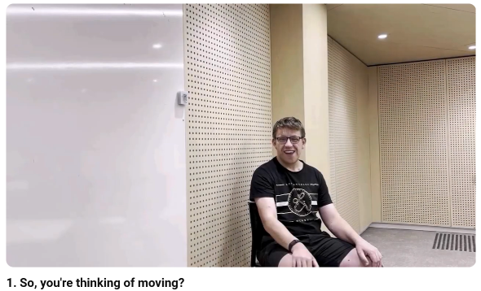
This is an Easy Read summary of the video called So you’re thinking of moving.



The video is about moving out of home.


The video can help you to start thinking about moving out.

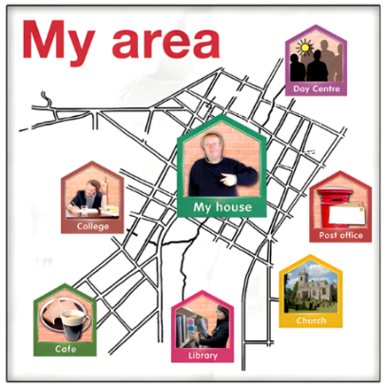
Some things to think about are

- What area you want to live in

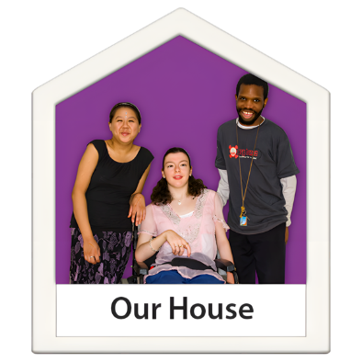

- Who you want to live with

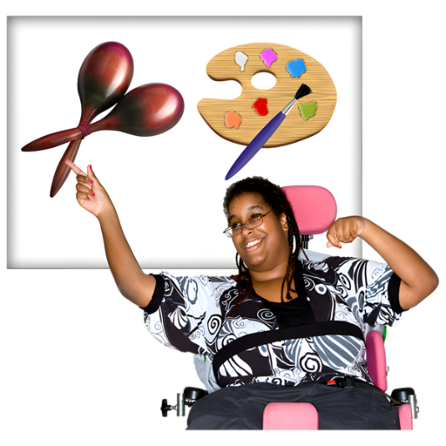

- What things you want to do



- What transport you want to use.


You might use your National Disability Insurance Scheme (NDIS) plan to help.

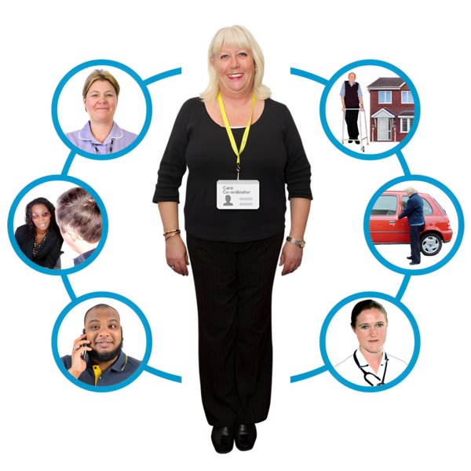

You can talk with your support coordinator about this.

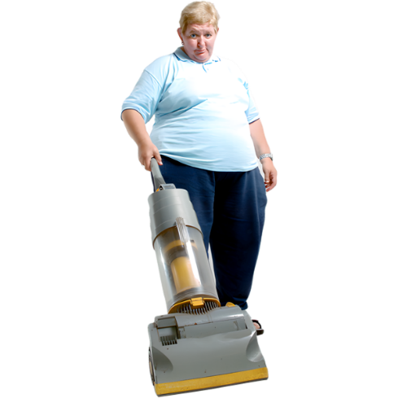
Do you feel confident doing things like cooking and household chores?



You can get help to practice these things.


You can get help from

- Family

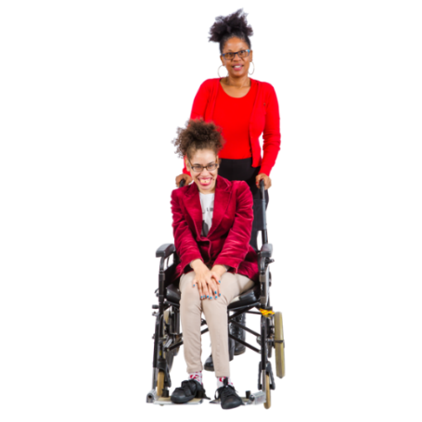

- Disability support workers

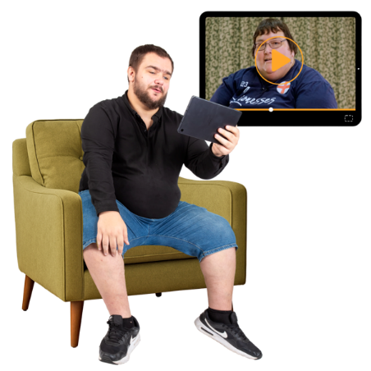
- Watching videos online

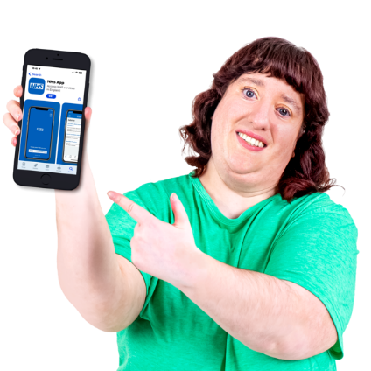
- Apps

An app is something you can put on your computer, tablet, or phone to help you do things.
Here are some links to other helpful resources for moving out.

- NDIS – Home and living information
https://www.ndis.gov.au/participants/home-and-living

- Housing Hub – Available housing around Australia
https://www.housinghub.org.au/search-results?checkboxRent=true

- Summer Foundation – My housing preferences toolkit
https://www.summerfoundation.org.au/housing-resources/?_sft_post_tag=housing-resources

- Summer Foundation – Things that helped me move video
https://www.youtube.com/watch?v=wPiCk-aVYAo

- United Response – CookABILITY cooking series
https://www.youtube.com/playlist?list=PLl79ZsuMB5bYbVZduF8_-jl_fPwpMqsCv

- Disability Gateway – Support for cleaning and household chores by state and territory
https://www.disabilitygateway.gov.au/everyday-living/cleaning

- Adult Down Syndrome Centre – Chore chart and videos
https://adscresources.advocatehealth.com/resources/chore-chart/











This project is funded by the Australian Research Council Linkage Grant (LP200200326). It has been approved by the Flinders University Human Research Ethics Committee (4635).

