


- Talking to family and friends

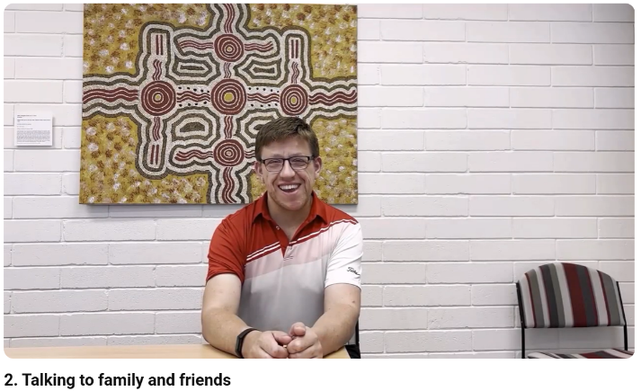

This is an Easy Read summary of the video called Talking to family and friends.



The video is about moving out of home.



The video is about how family and friends can help you move out.

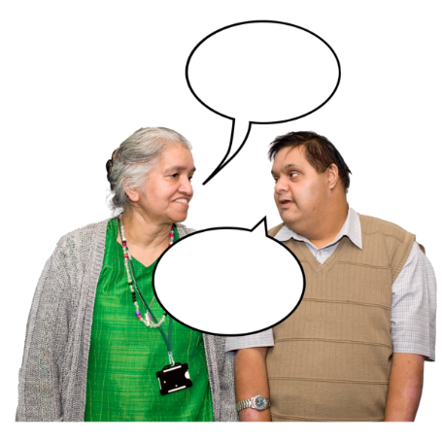
You can talk to family and friends about moving out.



You can share your goals for moving.



You can talk about what worries you about moving.



Family and friends can give you advice.


You can create a Circle of Support or a Microboard.

A Circle of Support or a Microboard is a group of people you choose to support you.


You can meet with them to help you when you need.

Here are links to other helpful resources for moving out.

- The Housing Hub – Available housing around Australia
https://www.housinghub.org.au/search-results?checkboxRent=true
- Imagine More – Tips for moving out, including talking to parents
https://imaginemore.org.au/wp-content/uploads/Settling-Into-Your-New-Home.pdf
- Circles of Support and Microboards – Explains what Circles of Support are
https://cosam.org.au/national-resource-centre/circles-of-support/
- Microboards Australia – Explains what Microboards are
https://microboards.org.au/microboards-community/what-is-a-microboard/











This project is funded by the Australian Research Council Linkage Grant (LP200200326). It has been approved by the Flinders University Human Research Ethics Committee (4635).

