
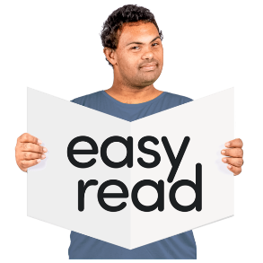

- Getting furniture doesn’t have to be hard

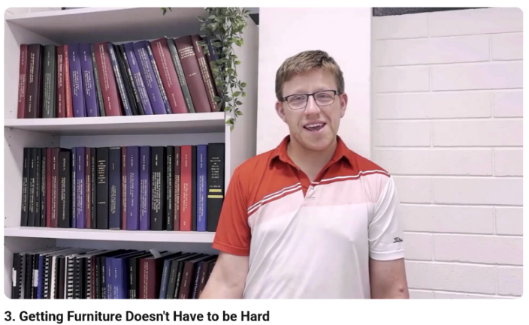

This is an Easy Read summary of the video called Getting furniture doesn’t have to be hard.

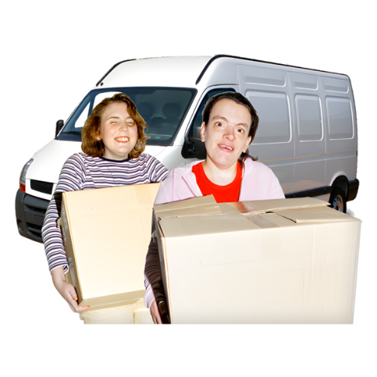

The video is about moving out of home.



The video is about things you can do that make moving out easier.

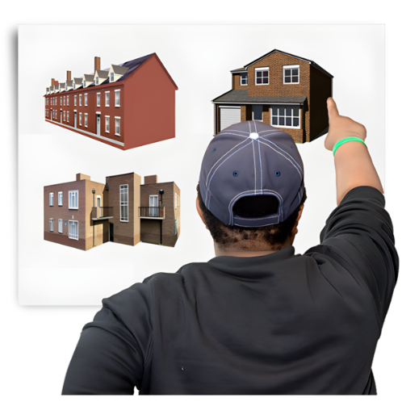
Have you already found the house you would like to move into?

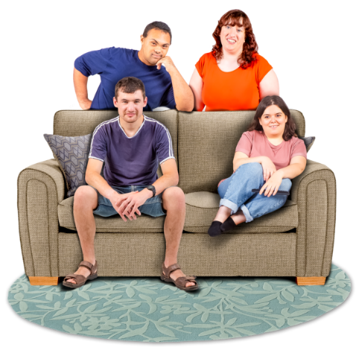
Do you already know who you will move in with?

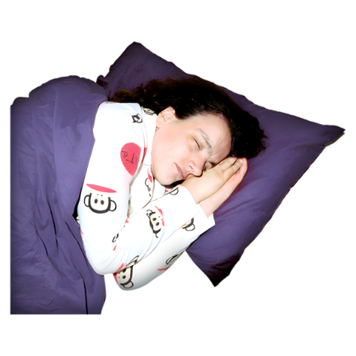

You can sleep over at your new house before moving in.


You can get to know your housemate before moving in.

Maybe you can have a coffee together or go out for dinner.
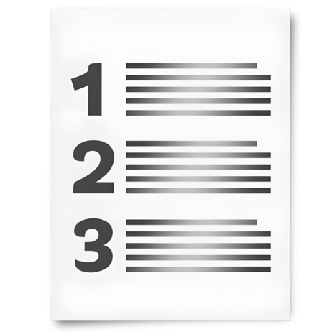
You can make a list of the things you will need to move out.

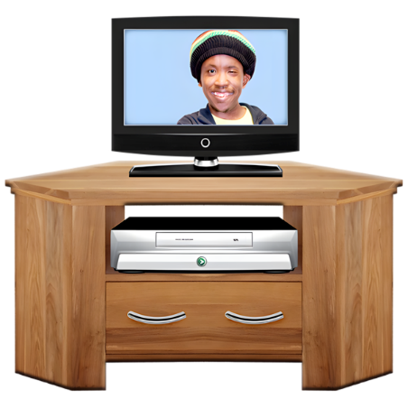
You can make a list of the furniture you want.

You might already have some things you can use.


You do not need everything straightaway.

You do not have to spend a lot of money.

You can go to second hand stores.

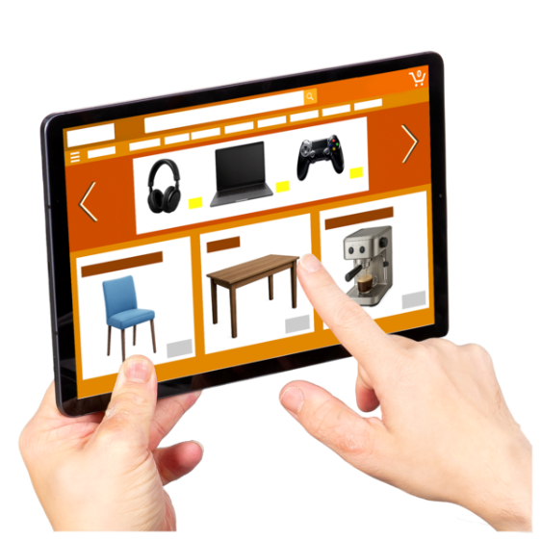
You have the right to have furniture you like.


You can get help from

- Family

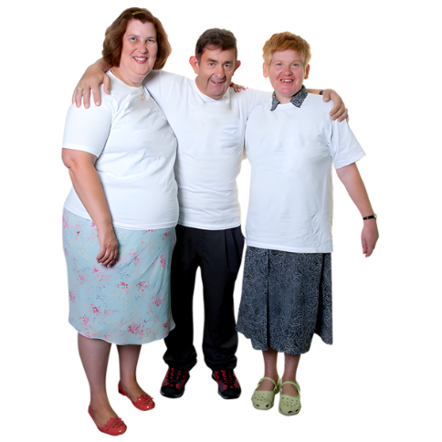

- Friends


- Disability support workers.

Here are links to other helpful resources for moving out.

- The Housing Hub – Available housing around Australia
https://www.housinghub.org.au/search-results?checkboxRent=true

- Summer Foundation – Things that helped me move video
https://www.youtube.com/watch?v=wPiCk-aVYAo

- United Response – CookABILITY cooking series
https://www.youtube.com/playlist?list=PLl79ZsuMB5bYbVZduF8_-jl_fPwpMqsCv

- Disability Gateway – Support with cleaning and household chores by state and territory
https://www.disabilitygateway.gov.au/everyday-living/cleaning

- Adult Down Syndrome Centre – Chore chart and videos
https://adscresources.advocatehealth.com/resources/chore-chart/

- Council for Intellectual Disability - Manage your money toolkit
https://cid.org.au/wp-content/uploads/2020/10/Manage-Your-Money-Easy-Read-Infoguide-CID.pdf


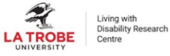








This project is funded by the Australian Research Council Linkage Grant (LP200200326). It has been approved by the Flinders University Human Research Ethics Committee (4635).

