
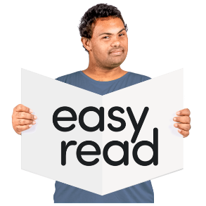

- Checklists and emergency contacts
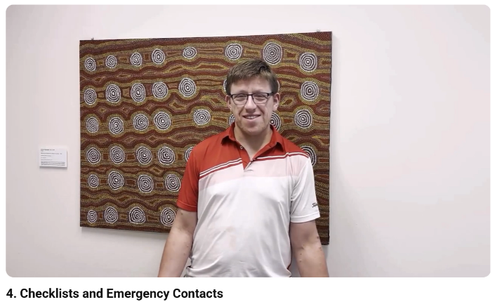

This is an Easy Read summary of the video called Checklists and emergency contacts.



The video is about moving out of home.

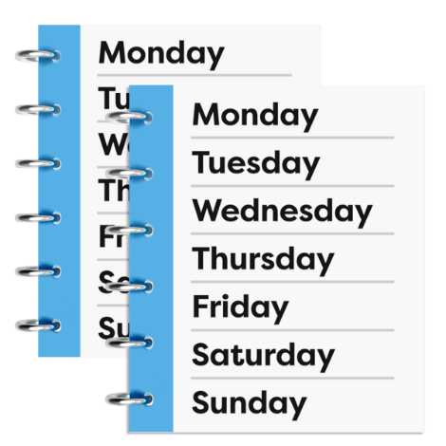

It is about doing things to help you be organised in your new home.

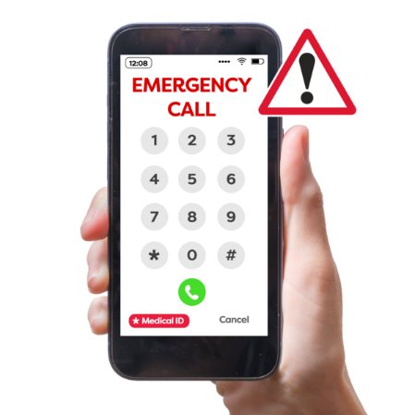
It is also about planning for emergencies.

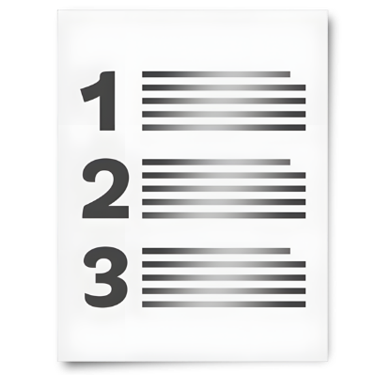
You can make a checklist of food you should always have in your pantry, like pasta or rice.

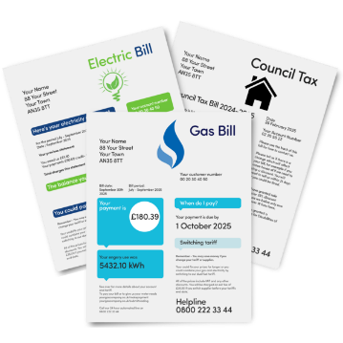
You can make a checklist of your bills.

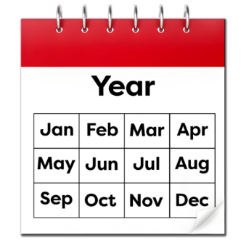
You can write all your appointments in a calendar.

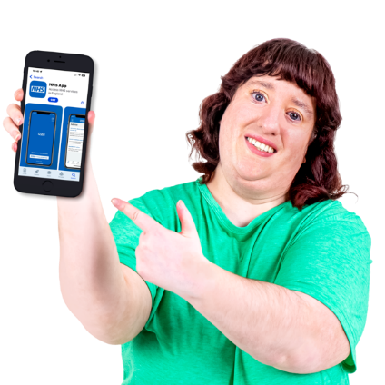
You can use apps to do these things as well.

Apps are something you can put on your computer, tablet, or phone to help you do things.

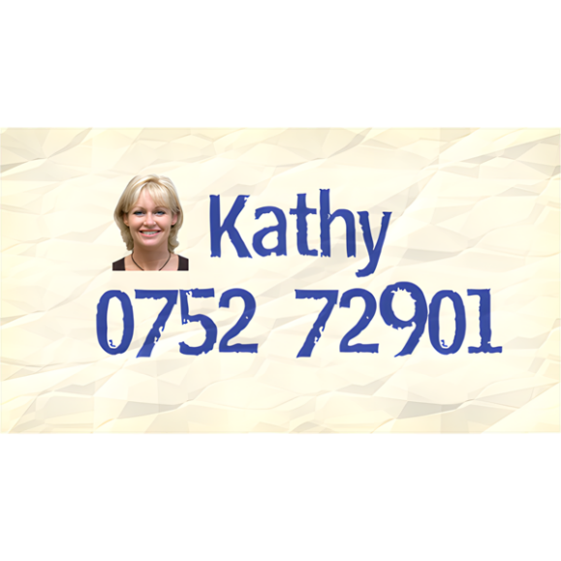
Make sure you have the contact details of the important people in your life, like your family.

Contact details are things like people’s phone numbers and emails.
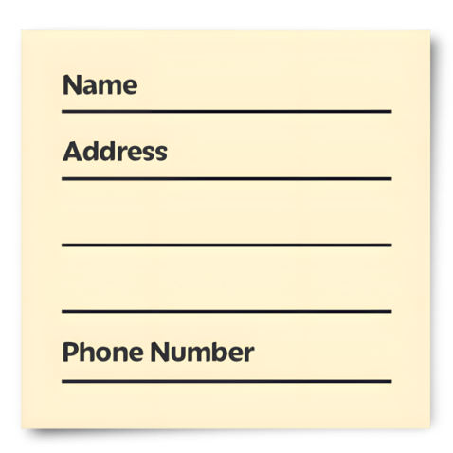

You can do this for the services you use as well, like your disability service provider.

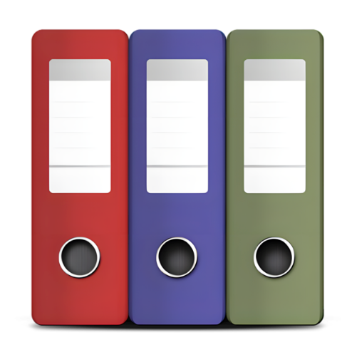
Make sure you keep these contact details in a safe place.

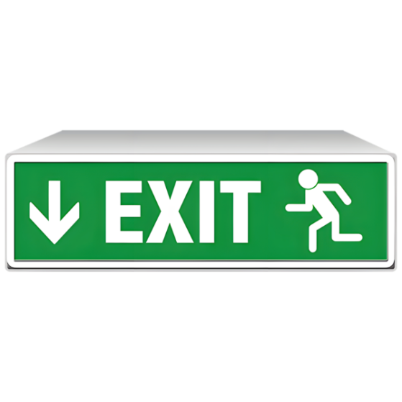
You can plan for emergencies as well.

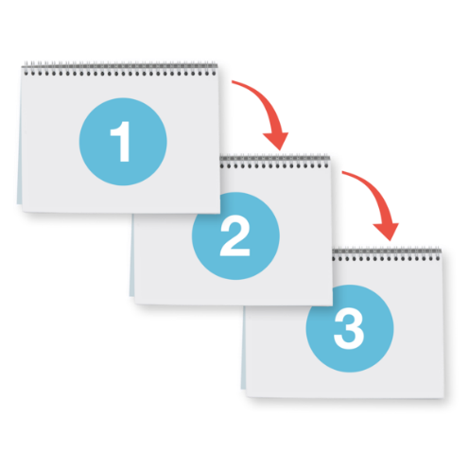

Like, you might want to write down what to do if the power goes out.

Here are links for other helpful resources for moving out.
- The Housing Hub – Available housing around Australia
https://www.housinghub.org.au/search-results?checkboxRent=true
- Australian Disability Clearinghouse on Education and Training – Technology to help stay organised
https://www.adcet.edu.au/inclusive-technology/intellectual-disability/prompting-scheduling-technologies

- Unison Disability – Best disability friendly apps
https://unissondisability.org.au/latest-news/the-best-disability-friendly-apps-in-2025/

- Disability Gateway – Emergency contacts and help template
https://www.disabilitygateway.gov.au/safety-help

- Council for Intellectual Disability – My safety plan toolkit
https://cid.org.au/wp-content/uploads/2020/07/My-Safety-Plan-CID-Jul20.pdf

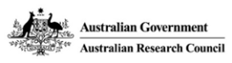

This project is funded by the Australian Research Council Linkage Grant (LP200200326). It has been approved by the Flinders University Human Research Ethics Committee (4635).

