


- Missing family, making friends, and support workers

This is an Easy Read summary of the video called Missing family, making friends, and support workers.



The video is about being in your new home.



This video can help you if some of your relationships have changed since you have moved out.


Now that you have moved out, things might be a bit different.

Some things might be exciting.


Other things might be stressful.



Maybe you miss your family and pet.


Make time to see you family.


Maybe you want to make new friends.



There might be groups in your area that you can join, like at the community centre.


Maybe you have more support workers than before.


Some of your support workers might be new.



Maybe you have support workers staying overnight.


Help support workers get to know you by making a short video about yourself.



You could also write a short profile.

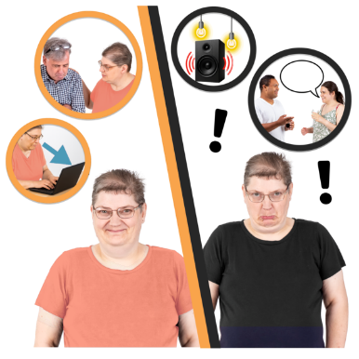

You can share your likes and dislikes.


You can also share your needs and wants.



It can be great to have more support to do the things you want.



It can also be overwhelming.


Let your support workers know if you are feeling overwhelmed.

Here are links to other helpful resources for moving out.

- NDIS Quality and Safeguards Commission – Tips for talking to support workers
https://workforcecapability.ndiscommission.gov.au/tools-and-resources/supervising-capability-working-together-participants
- United Response – CookABILITY cooking series
https://www.youtube.com/playlist?list=PLl79ZsuMB5bYbVZduF8_-jl_fPwpMqsCv
- Disability Gateway – Cleaning and household chores (support contacts by state)
https://www.disabilitygateway.gov.au/everyday-living/cleaning
- Adult Down Syndrome Centre – Chore chart and videos
https://adscresources.advocatehealth.com/resources/chore-chart/
- Council for Intellectual Disability - Manage your money toolkit
https://cid.org.au/wp-content/uploads/2020/10/Manage-Your-Money-Easy-Read-Infoguide-CID.pdf












This project is funded by the Australian Research Council Linkage Grant (LP200200326). It has been approved by the Flinders University Human Research Ethics Committee (4635).

