
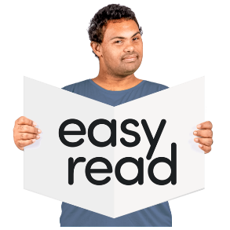

- Doing things your way

This is an Easy Read summary of the video called Doing things your way.

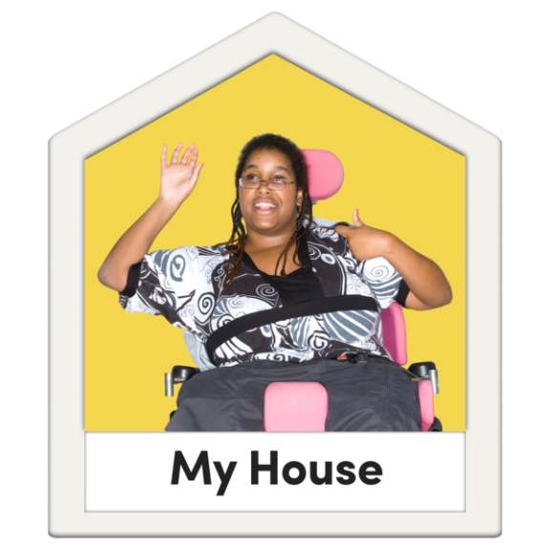

The video is about what it is like living in your new home.

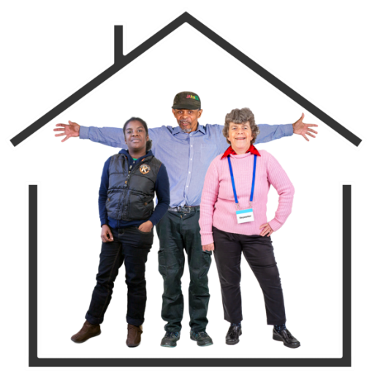

The video can help you to settle into your new home.

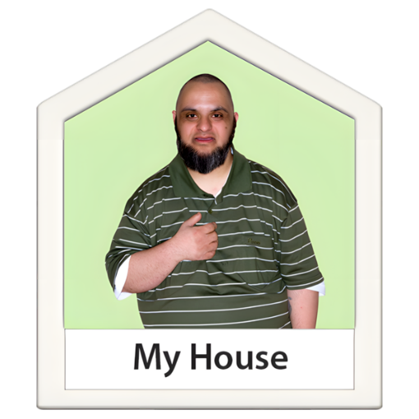
Since moving into your new home, you might be doing things your way more.

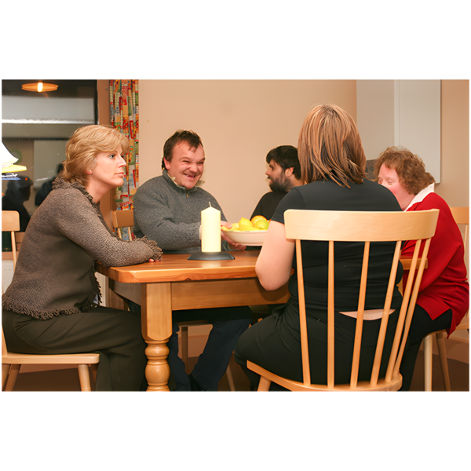

Your friends might stay over later.

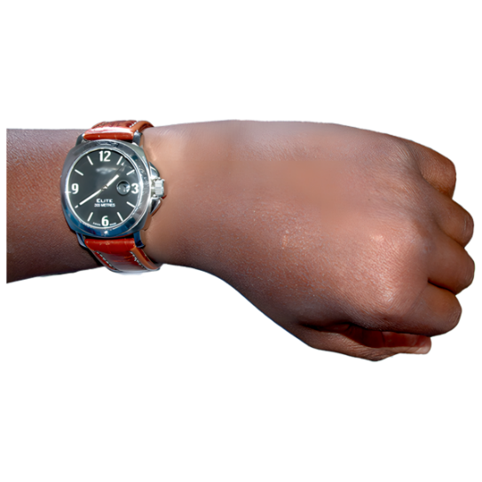

You come home later.

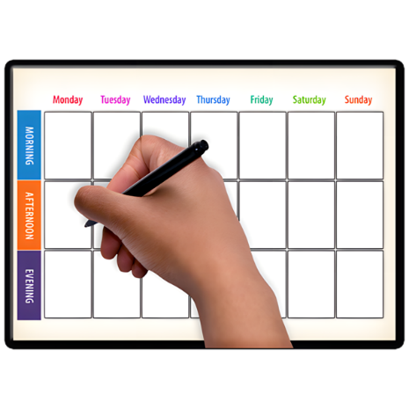
You might have more responsibilities.



This can be overwhelming.

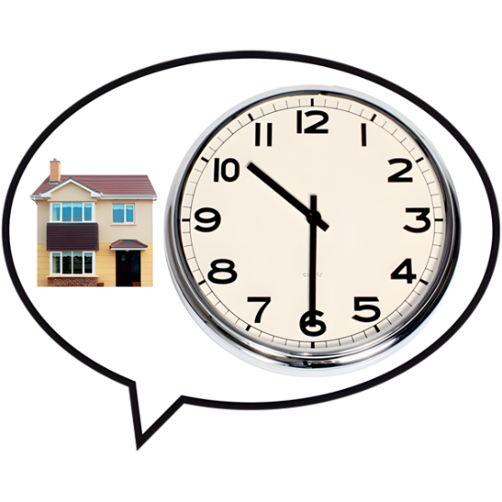

It can take time to get used to doing new things.

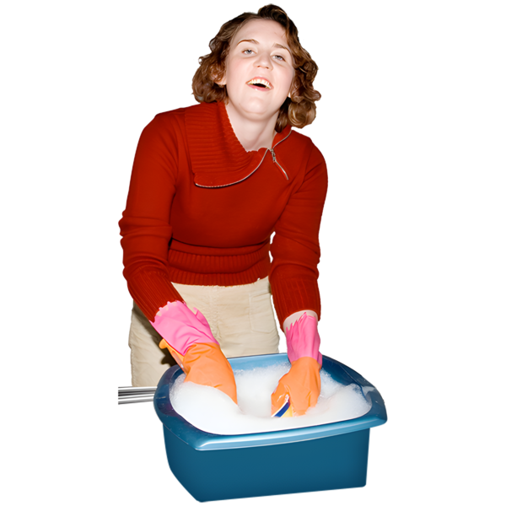

The more practice you get, the better you will get at it.


You can talk about how you feel with

- Family

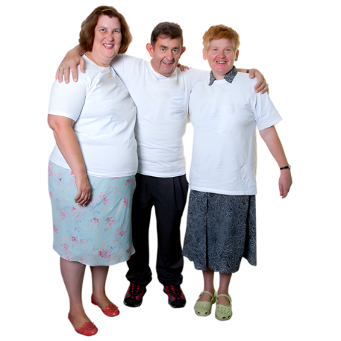

- Friends

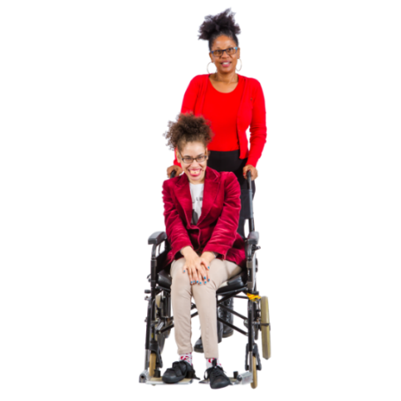

- Disability support workers.

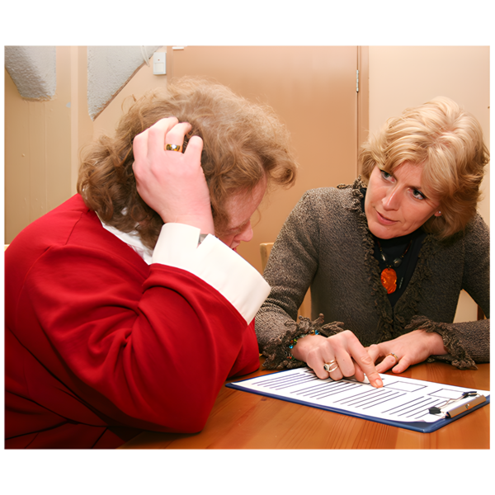

You can ask for more help if you need too.

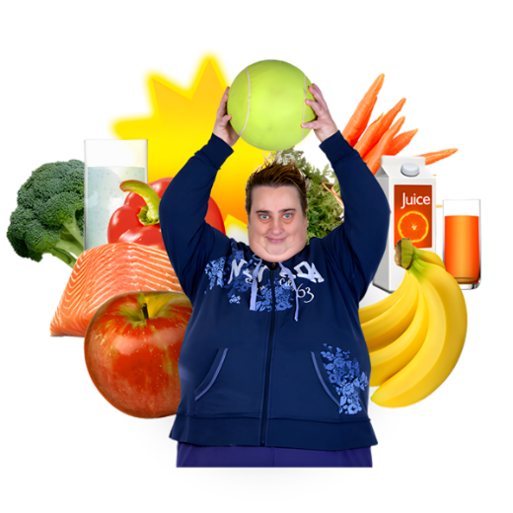
It is important to keep doing things that are good for you, like eating well and exercising.

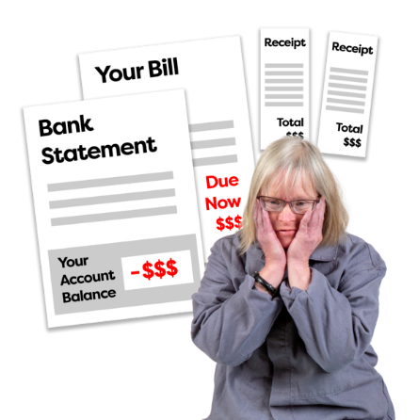

It is also important to stick to your budget.

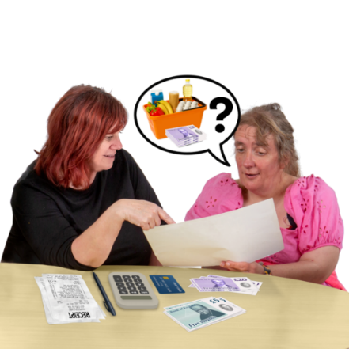

You can get help with your budget.

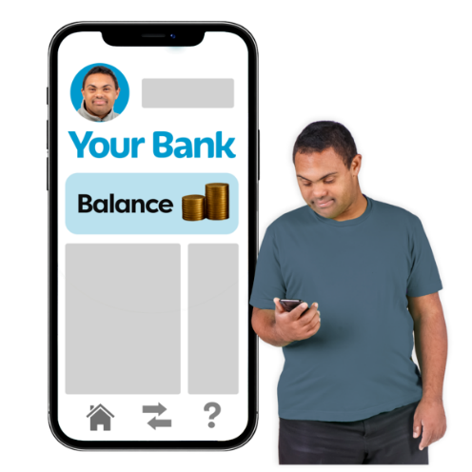
There are tools to help you online too.

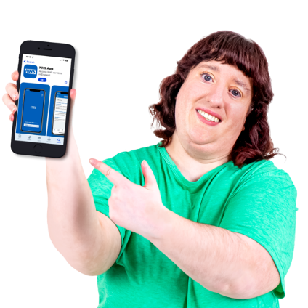
You can also use a budgeting app.

An app is something you can put on your computer, tablet, or phone to help you do things.

Here are links to other helpful resources for moving out.

- Council for Intellectual Disability – Making my own decisions toolkit
https://cid.org.au/resource/making-my-own-decisions/

- Council for Intellectual Disability - Manage your money toolkit
https://cid.org.au/wp-content/uploads/2020/10/Manage-Your-Money-Easy-Read-Infoguide-CID.pdf

- Disability Mental Health Connect – Information about good mental health
https://idmhconnect.health/index.php/about-mental-health-and-id/ER

- Women with Disabilities Australia - Healthy living tips and resources
https://oursite-easyread.wwda.org.au/life-choices/healthy-living/



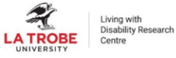



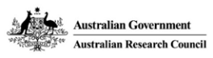




This project is funded by the Australian Research Council Linkage Grant (LP200200326). It has been approved by the Flinders University Human Research Ethics Committee (4635).

