
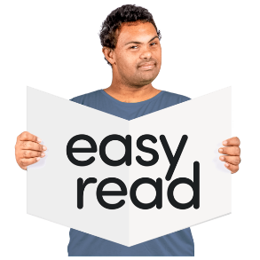

Making the Move – Welcome Video

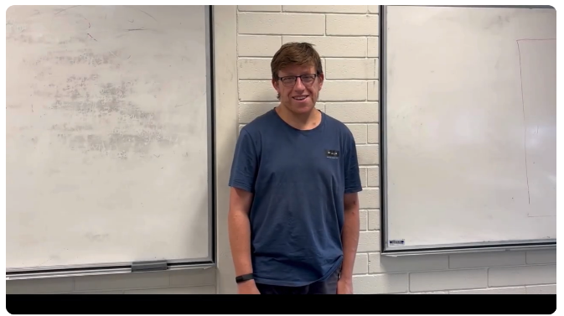

This is an Easy Read summary of the Making the move – Welcome video.



The video is about the research project called Making the Move.

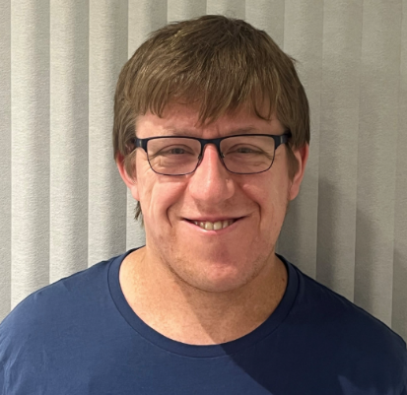
Ben is the co-researcher on the project.

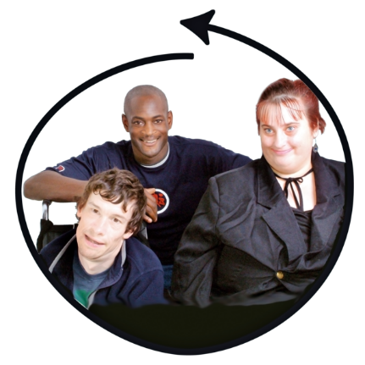
A co-researcher helps to makes sure research is inclusive.

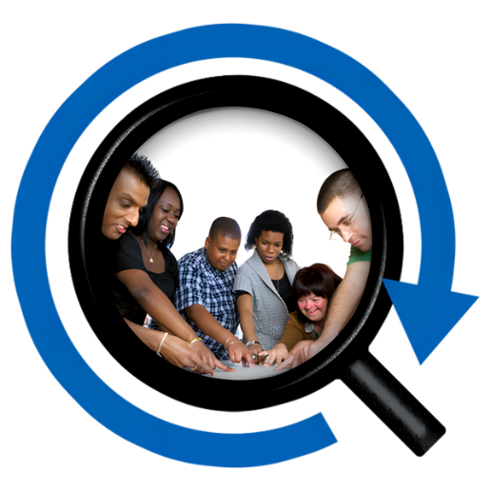

Inclusive means people with intellectual disability are involved in all parts of the research.


Making the Move is about supporting people with intellectual disability to move out of the family home.



There are 6 videos in the series.



There are tips for moving out in the videos.


There are also tips for settling into your new home.

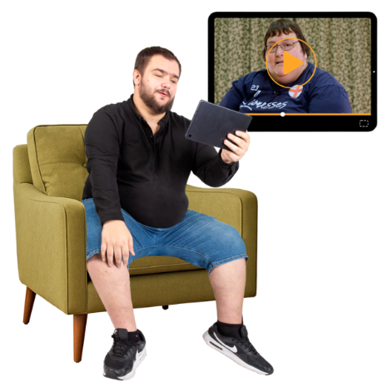
The videos are for people with intellectual disability.

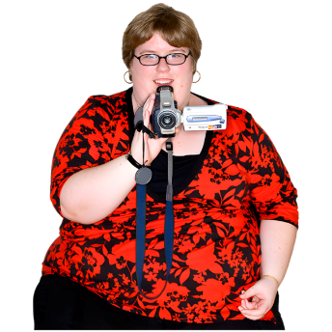

They have been made by people with intellectual disability.

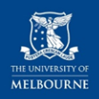

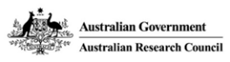
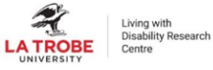






This project is funded by the Australian Research Council Linkage Grant (LP200200326). It has been approved by the Flinders University Human Research Ethics Committee (4635).

