


Moving Out of Home: What Was It Like?
What adults with intellectual disability and their families said


This is an Easy Read summary of a research article. It tells you about how adults with intellectual disability and their family felt about moving out of home.


How did we do the research?
We talked to 25 people:

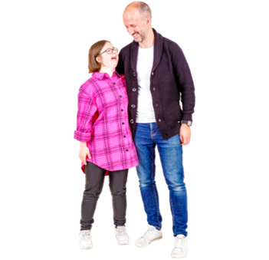
8 people with intellectual disabilities

17 family members

Some things we asked adults with intellectual disability were:
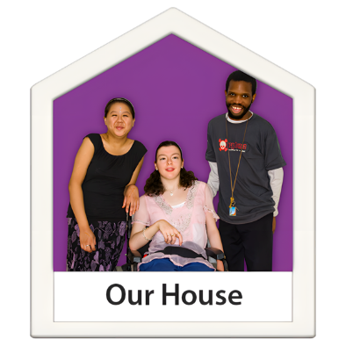
- How do you feel about where you live now?

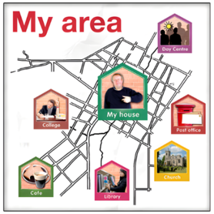
- What do you like about where you live?


- What do you not like about where you live?

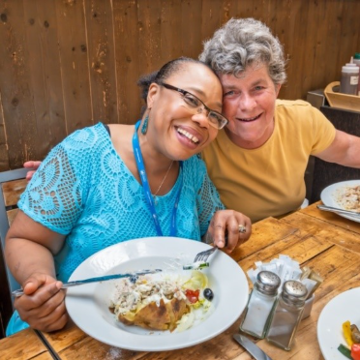
- What is the best thing about living out of home?

We also asked family members:
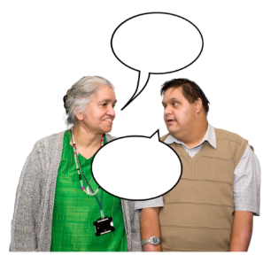

What went well when your family member moved out of home?



What do you do to support your family member now?


Are you worried about anything in the future?


Do you feel happy about how everything worked out?

What did we find?


We found three key areas which adults with intellectual disability and their family talked about.

1. Making your own choices and keeping family involved

- People felt good because they had ​
their own space.​
​


- Having more choice also felt good.​
But it was hard sometimes.​
​


- Moving out and trying new things ​
was exciting. It could be stressful ​
too.​



- Many family members wanted their relative to have more independence. They also found this change difficult.

2. Feeling comfortable with new housemates and support workers


- Some people lived with housemates. ​
Sometimes this was easy. And ​
sometimes it was hard.​


- Choosing the right housemates is important. People wanted to meet their housemates before moving in.

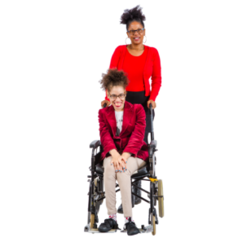
- Some people socialised with​
support workers a lot. Sometimes ​
they liked this and sometimes they ​
did not.​


- Some people found it difficult at first to have support workers in their home.

3. Being part of the community and meeting new people
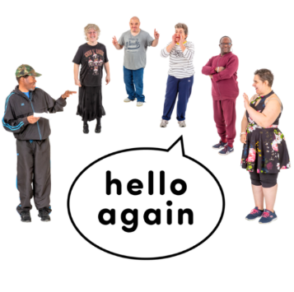
- Some people met new people when they moved out of home.​
​


- People liked knowing their ​neighbours.​

- Some family members said moving out of home helped their relative make new friends and join more activities in the community.

What is important to learn from this research?

People with intellectual disability said moving out of home meant they could do more of what they wanted to do.


Family members also saw positive changes.

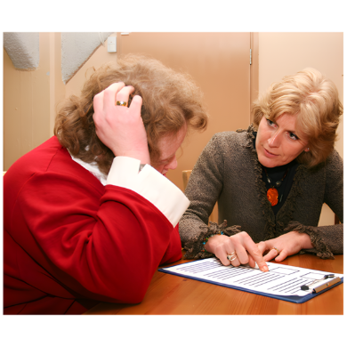
Some family members found it hard to step back while still wanting their relative to be safe and helped.

Want to read more? You can find the full research article here [LINK]

This project is funded by the Australian Research Council Linkage Grant (LP200200326). It has been approved by the Flinders University Human Research Ethics Committee (4635).









